**GREETINGS FROM YOUR PRESIDENT**

Many of us have been able to get a jump on early spring activities due to the exceptionally early ice out this year. It is time to gear up on UHLA activities too.

The annual meeting is set for Thursday, June 13th for a burger night at the Pequot Lakes American Legion starting at 5:00 P.M. A statistician from the DNR will be the speaker.

The annual Boat Parade will be held on July 4th. Boats should gather at the boat landing at 3:00 P.M. Prizes will be awarded this year for highly decorated boats as well as patriotically decorated docks. A game night at Snarky Loon or the Jenkins VFW is in the planning stages. More details will be announced at the annual meeting. Please mark your calendars and plan on attending these events.

A UHLA registration form for 2024 is attached to this issue. Please complete it and mail it with your dues to Brad Kaus, Treasurer.

A Board committee met in late summer to discuss updating the UHLA shoreline grant procedure. It is a complicated issue. The committee agreed that UHLA should follow state guidelines. Any changes to the shoreline grant procedure were tabled until more information could be gathered. To facilitate this process, Neil Beaverson attended a meeting with a Crow Wing Soil and Water representative in December 2023. Neil believes that UHLA Considerations should include the following: A. Pay or Copay for onsite inspection. B.  Pay upfront as incentive to get inspections and start the process.  C. Ask for volunteers to assist with projects within the association.  He noted that the key is to start the process early. The quality of Upper Hay Lake is a priority for our association. Get informed and get involved, but most of all ENJOY our beautiful Upper Hay Lake!

*–Brad Schultz*

# # # # #

**AQUATIC INVASIVE SPECIES UPDATE**

This is from an email sent out by Amy Stoneking, Environmental Services Coordinator for Crow Wing County Land Services on March 21, 2024:

“We wanted to reach out and give you all an update on AIS information and our program. We had first rounds of interviews last week and this week. We are up to 33 inspectors for the summer and hoping to hire 25 more…

…We have a link to some great information on AIS detectors program. It goes over how the program works, what to look for, and how to become one.  This is a great opportunity for anyone looking to get involved and become hands on in the Aquatic Invasive species research.”  https://maisrc.umn.edu/ais-detectors

--*Brad Schultz*

# # # # #

**DNR ANNOUNCES PLANS TO MODERNIZE BOAT ACCESS ACROSS THE STATE**

Modernizing Boating Access DNR-operated public water accesses need significant investment to make them accessible to all users, meet the needs of modern watercraft, improve protection of public waters from stormwater runoff and invasive species, and enhance climate resilience. A $35 million investment will allow DNR to renew and rehabilitate more than 100 public water accesses to serve anglers, boaters and paddlers across Minnesota.

The Minnesota DNR has identified more than 40 public water access sites throughout the state for extensive upgrades. This work, which is part of the historic Get Out MORE initiative, will be coordinated with ongoing baseline investments to ensure the efficient use of all funds. Lower Hay Lake is one of the Large-Scale Public Water Access (PWA) Modernization Projects.

Smaller-scale improvements to more than 75 additional accesses are also on the way.

*--* *https://www.dnr.state.mn.us/aboutdnr/get-out-more/index.html*

# # # # #

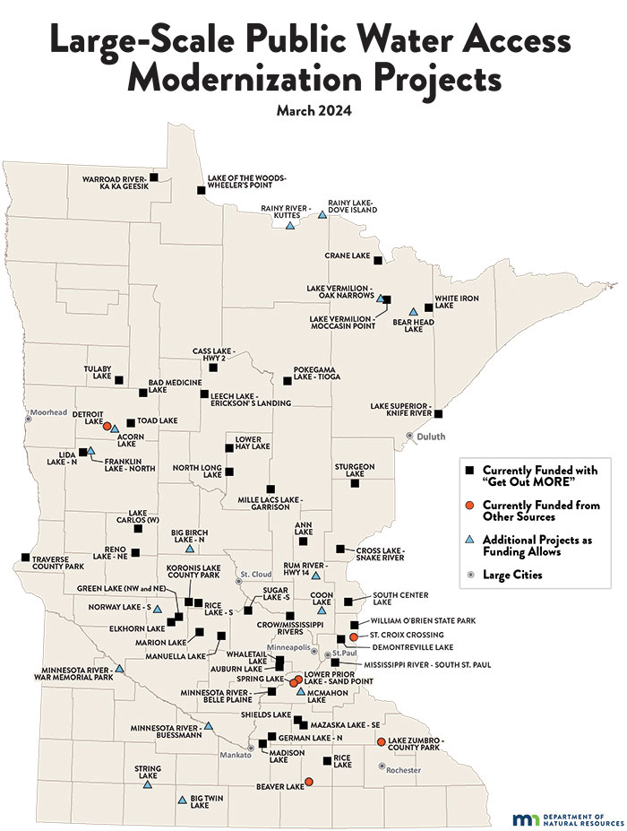

**SUMMARY OF THE PINE RIVER WATERSHED UPPER HAY LAKE IMPLEMENTATION PLAN**

According to the online PDF on the plan, “In 2018-2019, Crow Wing and Cass Counties, Soil and Water Conservation Districts (SWCDs) and citizens partnered to develop a comprehensive watershed management plan for the Pine River... …The plan characterized Upper Hay Lake as having stable water visibility (water clarity), high sensitivity to phosphorus, and high economic significance to the community. The plan categorized the lake and land as Protection Management. This plan does not address Aquatic Invasive Species (AIS) because Counties have their own AIS Plan.”

This plan set numerical, measurable goals to achieve in the next 10 years. Upper Hay Lake project status related to these goals is indicated by

phosphorus reduction, shoreline restoration, shoreline and land protection, monitoring, and

groundwater. The PDF of this plan has impressive graphics and detailed explanation of the plan. It provides an introduction with the focus and rationale for the plan. It details why the plan matters in relation to property values, fishing, recreation, and habitat. It provides information on taking good care of the lake. It shows a chart on what private landowners can do to help improve lake water quality and achieve watershed plan goals by implementing various projects. Technical and financial assistance is available to help with these projects. The document shows a map of impervious surfaces surrounding the lake with pertinent information on its importance. Map #2 is about protection. This map shows each parcel in the land area that drains towards the lake. Parcels that are red or orange are the highest priority for increasing protection of the land. Landowners in these high priority areas can contact the SWCD for protection options such as Forest Stewardship Plans, the Sustainable Forest Incentive Act, and Conservation Easements. Map #3 depicts wells and septic systems. The groundwater in the Pine River Watershed is very shallow and the soils are sandy, which is called a surficial sands aquifer. This shallow nature makes the groundwater susceptible to contamination. Septic tanks and holding tanks, if not properly maintained, can leak into the ground and reach the groundwater, which makes it unsafe to drink. The area around your wellhead should also be protected so that contaminants can't seep into the groundwater and your well. Don't park your car, apply fertilizer or chemicals, or dump waste near your wellhead. Any unused wells should be sealed to 1) prevent children and animals from falling in, 2) prevent contamination from entering the groundwater, and 3) prevent liability issues with old, unused wells. Contact a well driller to seal any unused wells. This map shows the locations of wells around the Lakeshore. It is assumed that where there are wells there are also septic systems. Property owners can refer to the Groundwater section on page 4 for guidance on properly maintaining their septic system and protecting their drinking water. UHLA members are encouraged to go to the following website to find this PDF:

https://www.crowwing.gov/DocumentCenter/View/18050/Upper-Hay-Lake-Plan?bidId=

# # # # #

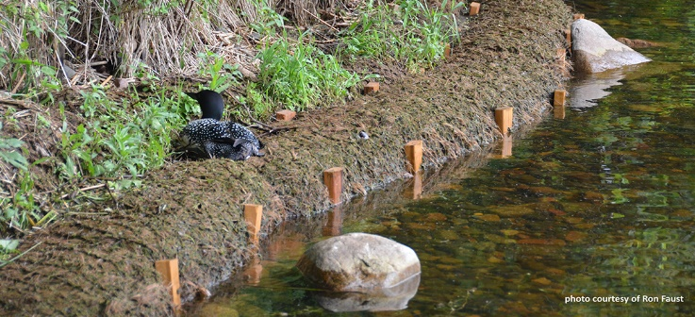

**PROCEDURE FOR WORKING WITH CWSW FOR PERMITS ANDD FUNDING OF SHORELINE RESTORATION**

There was a meeting with Adam Maleski of Crow Wing Soil & Water (CWSW) on December 14th 2023. The purpose of the meeting was to discuss the procedure for working with CWSW for permits and funding of Shore Line Restoration. Here are the main points discussed:

1. Applications for onsite inspection.  Apply online: Name, address and contact information is all that is required.  Approximately 70 shoreline inspections per year for CW county; Cost is $150. A CWSW technician will provide a report with recommendations within 3 weeks of inspection.

2. CWSW can write a plan for restoration ($60/hour) or provide a list of approved contractors(many) to write a plan for restoration.  If only planting of upland vegetation is to be done a CWSW approved plan is not necessary but highly recommended.

3. Permits:  All work below high-water mark or a change in grade above high water mark requires a country permit; the cost is $300. Rip Rap and other shoreline modifications or aquatic vegetation planting requires MN DNR permit. CWSW will advise on what permits are needed and what agency to apply to, but CWSW does not issue permits. Availability of Funding ($635,000 Annually**)** for entire county.  All projects are ranked based on expected benefit to watershed, and funding is provided based on this ranking.  Typically, maximum of 50% funding per project until budget is used up.  Greater than 50% funding is possible but requires exceptional circumstances (i.e. no money and serious threat in watershed if project not carried out).

Other Discussion:

One Watershed one Plan

Pine River Watershed Management Plan for Upper Hay Lake (10 year plan)

--Neil Beaverson

# # # # #

**TREASURER’S REPORT**

During 2023 we worked to pick up the treasure duties and activities from long time treasure Ken Meyer. This included accessing back accounts and recovering the financial record Ken kept. We also moved the banking accounts to a local credit union in Pequot Lakes. Thanks to the board members who assisted in this effort.

The fiscal year for our association runs with the calendar year ending on December 31, 2023. Our total asset balance was $46,561.49 in various accounts. We recorded 75 members paying their dues in 2023.

Everyone will be receiving their 2024 Membership Application with this newsletter. Please fill it out and return it now so it doesn't get lost in the shuffle. We will be collecting dues from everyone attending the June 13, 2024, meeting if you have not paid prior to the meeting.

*---Brad Kaus*

# # # # #

**AIS DETECTORS**

Want to help prevent the spread of Aquatic Invasive Species in North Long Lake?  You can be certified as an AIS detector with training through the UoM's Minnesota Aquatic Invasive Species Research Center. This course consists of two portions: a self-paced online course and a live workshop with the instructors. The self-paced online course takes approximately 8 hours to complete, followed by either a one day in-person workshop or two 3-hour virtual workshops via Zoom.  
  
There is a live class in Hackensack on May 31st and the online class is June 4-5.  Registration for the Hackensack option is available at no cost to you this year thanks to sponsorship from the Association of Cass County Lakes and Cass County.  More information at <https://maisrc.umn.edu/detectors-core>

**ICE RIDGE DAMAGE**

Crow Wing County Land Services is reminding property owners affected by ice ridges this winter the options for repairing shoreline damage. Before repairing shoreline damage, property owners should consult the Land Services Department or their city/town zoning office for a review of applicable rules.  
   
The Crow Wing County Land Use Ordinance allows an annual ice ridge to be re-graded back to its original elevation without a permit when the work is done in the same year the ice ridge occurred.  Annual ice ridges are defined as a linear mound of lakebed materials pushed up onto the lakeshore by the action of ice within a calendar year.  
  
It is important to remember that the soil from the annual ice ridge cannot be pushed back into the lake and must be graded back away from the lake. Erosion and sediment control measures such as a silt fence must be implemented before any work is started on the project.

*--- North Long Lake Association Newsletter, April 2024*

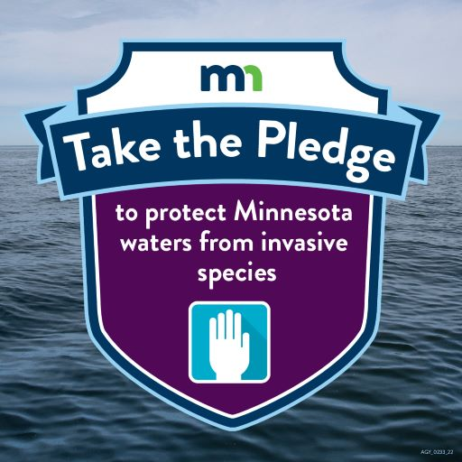

### PLEDGE TO PROTECT MINNESOTA WATERS

Pledge to protect Minnesota waters from aquatic invasive species. These AIS are plants, animals and diseases that do not naturally occur in our waters and may cause harm to the environment, the economy, human health or natural resources. Your pledge demonstrates your commitment and care to prevent the spread of AIS in Minnesota. [Take the pledge](https://www.dnr.state.mn.us/data/ais-pledge).

**UPPER HAY LAKE ASSOCIATION BOARD OF DIRECTORS 2023-2024**

|  |  |  |  |  |
| --- | --- | --- | --- | --- |
| **NAME:** | **LAKE & HOME ADDRESS:** | **PHONE:** | **EMAIL:** | **TERM ENDS:** |
| Beaverson, Neil  *Vice President* | 33904 Oak Dr.  417 Bear Ave. S.  Vadnais Heights, MN  55127 | 651-429-6672 | nmbeaverson@comcast.net | 2026 |
| Kaus, Bradley  *Secretary and Treasurer* | 4649 County Rd. 145 | 612-309-3584 (cell) | bgkaus@gmail.com | 2025 |
| Larson, Whitey | 33061 W. Shady Beach Lane | 218-568-5831 | whiteylar@me.com | 2025 |
| Nelson, Maddie | 33127 S. Upper Hay Drive | 218-820-9461 (cell) | maddie@lgkwpro.com | 2026 |
| Obermiller, Dan | 33113 Osprey Circle | 763-355-7999 (cell) | dano.obermiller@gmail.com | 2024 |
| Schultz, Brad  *President* | 33143 Osprey Circle | 952-393-1758 (cell) | bvschultz55@gmail.com | 2026 |
| Steen, Claire | 33161 Osprey Circle  29 Kingwood Street  Brainerd, MN 56401 | 218-829-3757  218-330-7059 (cell) | Claire.steen@charter.net | 2024 |
| Woodruff, Jack | 4861 Popple Trail | 612-802-3832 | woodruffgarden17@yahoo.com | 2025 |

**Note:  Unless listed otherwise, all addresses are Pequot Lakes, MN  56472**

**2024 Membership Application**

Name (s):

Lake Address:

|  |  |
| --- | --- |
| Summer Mailing Address (if different than lake address) | Winter Mailing Address (if different than summer address) |
|  |  |
|  |  |

Lake Phone: ________________ Cell Phone: ________________ Other Phone:

E-mail address:

Would you like to receive Newsletters etc. by e-mail rather than US mail? Yes ______ No

I am particularly interested in seeing the Lake Association do the following:

I would like to participate in the following committees:

|  |  |
| --- | --- |
| _____ AIS Monitoring | _____ Shoreline Restoration |
| _____ Public Access | _____ Fund Raising / Grant Writing |
| _____ Social Committee (Picnic / Breakfast) | _____ Other ______________________________ |

_____ I would like my name placed on the ballot for a Board of Directors position.

_____ Enclosed is my tax deductible membership dues of $25.

_____ Enclosed is my additional tax deductible donation of $__________ in support of UHLA’s mission to promote environmental stewardship throughout the Upper Hay Lake area.

Make check payable to Upper Hay Lake Association and mail to:

Upper Hay Lake Association

P.O. Box 769

Pequot Lakes, MN 56472

**Environmental Stewardship Today, for Tomorrow**