**GREETINGS FROM YOUR PRESIDENT**

As many of you know, Ken Meyer recently passed away. He was a long-time treasurer for our association. His dedication and service to the Upper Hay Lake Association was outstanding! He is missed.

Brad Kaus and Claire Steen have gathered the financial documents for the organization. They have also changed banks and reinvested our CDs at a much higher interest rate. Brad will share more about this in his report.

The Board met in September and formed a committee to study the grant process for shoreline restoration. The board would like to encourage responsible projects that align with governmental agencies’ recommendations and policies. Members of this group met over supper at Claire’s cabin with Cindy Reick. Cindy shared her experience with her extensive shoreline projects. We hope to have a revised process in place in the future, but it will not be ready for the 2024 summer.

We are moving to three newsletters annually and are emailing it from now on (except those who specifically request a paper copy to be mailed out).

I have spent time revising the website. Newsletters are now PDFs on the site. I have also added current photos. More work is needed to update the content.

We have decided to have our annual meeting in June again. More details will be announced later. Enjoy the fall colors and all Upper Hay Lake has to offer!!

*–Brad Schultz*

# # # # #

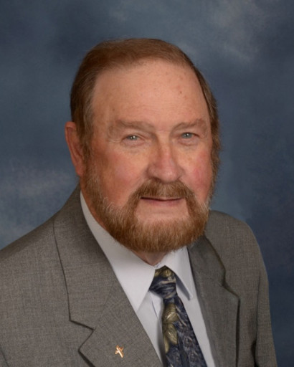

Kenneth W. Meyer

Kenneth “Ken” William Meyer, 84, passed away on September 22, 2023, in his home and surrounded by love, after a short battle with cancer. He was born on August 1, 1939 to William and Rose Meyer in Verdi, MN.

After graduating from high school in 1957, Ken served 10 years in the US Navy, much of his time spent aboard the USS Oriskany, an Essex-class aircraft carrier. After his military service, Ken moved to Minnesota with two of his three children and pursued a civilian career in the HVAC industry and worked 30 years for Commercial Air and The Egan Companies. He met his lasting love, Cecilia “Sally”, in the early 1970s and they were married on January 12, 1974. They lived in Maple Grove, attended Shephard of the Grove LCMS, and were active members of their community.

After “retiring” in 2001, Ken and Sally moved to Pequot Lakes, where he was active in his church, Pequot Lakes American Legion and other community organizations.

Ken was preceded in death by his wife, Sally; parents; and sisters, Marilyn (Paul) Herman and Norma (John) Ayres. He is survived by his sister, Marlys (Carroll) McDowell; his three children, Monica (Laura Thompson) McMillan, Byron (Judy) Meyer and Lisa (Ashworth Payne Jr.) Meyer; and one grandson, Chance Meyer.

Services will be 11:00 AM on Friday, September 29, at Gloria Dei Lutheran Church followed by a Celebration of Life at the American Legion Post #49, both in Pequot Lakes. Burial will be at Minnesota State Veterans Cemetery, Little Falls, at a later date.

*© Copyright 2023 Brainerd Dispatch and Forum Communications Company.*

# # # # #

# STATE OF WATER: HOW SUBURBAN HOME AESTHETICS ARE SCARRING MINNESOTA SHORELINENACE

**OCTOBER 5, 2023 / 7:00 PM / CBS MINNESOTA**

**GULL LAKE, Minn. —** If it's summertime, you are sure to find many Minnesotans at some of our state's 12,000 lakes.

But for years experts have warned that many of our habits are scarring these precious parts of summer.

Researchers will soon release new findings that show nearly 50% of Minnesota's natural shorelines have vanished. In their place are perfectly manicured lawns, manufactured beaches, and foliage covered in pesticides. Now, as lake water turns murky and wildlife starts to disappear, many lake property owners find themselves questioning their own impact on the shore.

"What's causing that is some homeowners are bringing their 'lawn down the lake' philosophy or their suburban view of what is a beautiful property and bringing it up north, or bringing it to their lake and changing the character of that shoreline," explained [Paul Randomski](https://paulradomski.com/), a lake ecologist with the DNR who has been studying the degradation of shorelines for 37 years.

"There's consequences of that kind of aesthetic," he added.

Gull LakeWCCO

The DNR says a mowed shoreline allows up to nine times more pollutants to run off than a natural one. Harmful chemicals such as phosphorus and nitrogen easily bleed into the water. Such chemicals increase weed growth and reduce water clarity.

"And that's a really challenging pollution to get your fingers around and address, because it doesn't come at the end of a pipe. It comes from land. You know, it's broadly distributed near the lake shore and up in the lake's watershed. So it's a really challenging problem to address," Randomski said.

**MORE:**[**PFAS in Minnesota: How "forever chemicals" changed the state of water**](https://www.cbsnews.com/minnesota/news/pfas-in-minnesota-how-forever-chemicals-changed-the-state-of-water/)

A mowed shoreline is estimated to produce 1/5 lbs of phosphorus per summer, which can result in 100 lbs of algae in the water. In contrast, a natural shoreline with proper vegetation cuts down on phosphorus and algae by 85%.

Not only does the stripping of shores allow pollutants to accumulate, it also fragments it, making it vulnerable to extreme weather and increased erosion. That can cause property and [wildlife to slowly disappear.](https://files.dnr.state.mn.us/waters/watermgmt_section/shoreland/shoreland-activities.pdf)

Alongside the state, nonprofits have been working to educate and usher homeowners into a more sustainable culture of landscaping. For many years, groups like Minnesota Lakes and Rivers Association have helped start and support lake associations across the state, arming them with educational resources in hopes of uniting property owners' efforts to protect the water.

"This is a role where lake associations are uniquely positioned, right, because they're the neighbors. And they're on site and they can start to support this change, this cultural change, this change in imagination, in a way that government can't really do it," said Jeff Forester, executive director of the [Minnesota Lakes and Rivers Advocates.](https://mnlakesandrivers.org/)

Lake associations can be an avenue for change - which is exactly what's happening on the shores of Gull Lake. One woman is encouraging others to make a difference to their properties.

Dorothy Whitmer had, for a long time, been an active member of a lake association. But in 2016, she received an email with a quiz that allowed her to rate the stewardship of her family's Lake Michigan property.

"I thought, I could rate my shoreline. I have a perfect yard with fertilizer and pesticides, and I'm going to ace this quiz. And 35 questions later I had a score that was pitiful, and I was just so disappointed, and I thought, 'now what?'" Whitmer said.

She was so impressed by the quiz, she said it inspired her to do something to protect the lake.

After years of researching and writing, Whitmer and the [Gull Chain of Lakes Association](https://www.gcola.org/) developed their own version of the ["score your shore" quiz](https://www.surveymonkey.com/r/92S2CCG), containing four easy questions. They sent out the first quiz on Memorial Day weekend of 2019 to over 600 members.

"And I really wanted people to respond, but I thought if we just get a handful of answers, we'll be okay. And so I waited three days and finally I peaked and we had 103 responses to this quiz, and it was so thrilling," she said.

**MORE:**[**A look at what's happened since Line 3 started operating in northern Minnesota**](https://www.cbsnews.com/minnesota/news/line-3-oil-pipeline/)

Soon after, Whitmer and the other members of GCOLA began the official lake steward program and started awarding those who scored well on the quiz. They celebrate owners with high scores by gifting them a sign that displays their participation in the program.

"We congratulate them on what they've done well. And then we I set up a time to go photograph. We get their dogs — one person had a rabbit and we assemble the family and we give them the award and it's just a thrilling time," she said.

The sign acts as a trophy for the work the property owners do to keep their own piece of the lake natural. Many recipients don them at the end of their docks or proudly display them amongst lush shorelines. For some it's a small act of rebellion against problematic suburban aesthetics, helping challenge the perception of what some might see as an unkempt lawn.The sign also encourages neighbors to start asking questions, which spreads the philosophy of [keeping a natural shoreline.](https://www.dnr.state.mn.us/lakescaping/maintaining-and-restoring-natural-shorelines.html)

WCCO

When quiz participants score poorly, Dorothy and her team provide resources and offer to work with property owners on their shorelines. They share suggestions that would help them properly restore their land while reaching the title of lake steward.

The program is working. The group has received 500 responses to the quiz over four years. They have 94 lake steward award winners restoring 3.3 miles of undeveloped natural shoreline on Gull Lake. The association and the DNR believe they have prevented approximately 1.5 tons of algae from entering the water since the program's inception.

While the accomplishments are impressive, experts say we still have a  to go in protecting our lake quality. In fact, researchers from the DNR believe that to achieve a reasonably protected shoreline - nearly 75% must be restored to its natural state.

It's a heavy lift for lake associations, including Gull, as just 30% is currently undeveloped.

"I really do feel we have to make it happen here. We've got everything going for us. And the message is so simple, do less, save money. So I really want to make it happen here," Whitmer said.

**So how do you restore your shore? The Lake Steward program provides an easy five step list to help you get started.**

1. Create a buffer zone.

Stop mowing your lawn down to the lake and create what's known as a buffer zone. It's an area from the waterline up towards the property that allows native grasses, trees, shrubs, and flowers to flourish in their wild state. The native plants not only stabilize and strengthen the shores, but they act as a barrier to harmful chemical runoff. A recommended buffer zone extends 25 feet from a shoreline.

2. Maintain septic systems

Minnesota Lakes and Rivers Advocates suggests scheduling septic system maintenance every 1 to 3 years. It is important to catch any malfunctions or leaks before they can make their way into the water.

3. Reduce impervious surfaces

Hards surfaces such as concrete, patios, and walking paths prevent rainwater from soaking into the land and heightens the risk of carrying a variety of harmful chemicals through runoff into the lake. Consider alternatives such as pavers or stepping stones.

4. Dispose of pet and fire pit waste

Pet waste also carries harmful nutrients and pathogens that can create toxic water conditions if they are not disposed of correctly. The ash from firepits is equally dangerous to lakeshores as it contains prominent levels of phosphorus. Keep firepits behind the buffer zone or at least 25 feet from the water's edge.

5. Allow fallen trees to remain If they do not get in the way of navigation, fallen trees create important habitats for the lake's ecosystem. The turtles, frogs, birds, and fish will thank you.

<https://www.cbsnews.com/minnesota/news/state-of-water-restoring-lake-shores/>

# # # # #

**CERTIFICATE IS AWARDED TO OUTGOING PRESIDENT CLAIRE STEEN**

Claire Steen, Outgoing President of UHLA was presented a certificate by Brad Schultz recognizing her many years of dedication and service to the organization at the Burger Night at the American Legion on August 3, 2023.*A group of people standing in a room
*

Terry and Mary Daniels with Steve Boulka in the middle are shown here visiting with one another at the Burger Night on August 3, 2023.

|  |
| --- |
| **THERE IS AN OPENING FOR A MEMBER TO SERVE ON THE UHLA BOARD OF DIRECTORS. PLEASE CONTACT ANY BOARD MEMBER IF INTERESTED IN SERVING ON THE BOARD. THANK YOU!!** |

Kathy Larson (Left), Greg Marolt (back left), Judy and Greg Murphy (right) and others enjoying their lake neighbors and friends at the Burger Night on August 3, 2023.

Jean Ford, long-time UHLA member attended Burger Night with members of her family.

# # # # #

**LIGHT POLLUTION INFORMATION**

Lake residents may want to consider the addition of a sensor to security lights rather than having them on all night. Also, officially certified as an International Dark Sky Park, Voyageurs National Park in northern Minnesota is one of the best locations in the state for exceptionally high quality dark night skies and stargazing.

<https://mn.audubon.org/conservation/light-pollution-solutions>

<https://www.bellmuseum.umn.edu/blog/shaw/>

*---Brad Schultz*

# # # # #

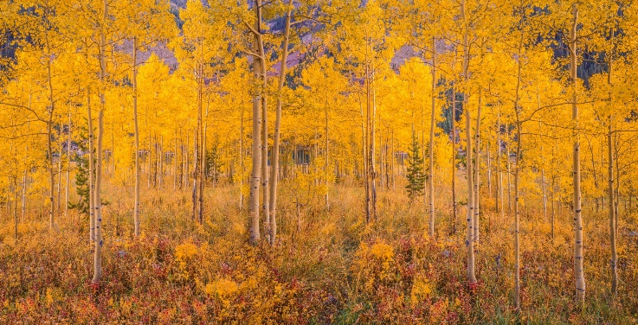

**TREASURER’S REPORT**

Several of the board members have been busy working through the information Ken left with us as we gain access to accounts and move these so we can best serve the members. The banking will be moved from several banks holding CDs and accounts into a single location at MidMinnesota Credit Union in Pequot Lakes. This allows us to increase the rates on the CDs, back in a local business and simplify our banking needs.

With this completed, I am turning my attention to reconciling receipts and understanding the bills that need to be paid. I am also looking at the member roster to make sure we understand who paid due in 2023 and are ready to for 2024 to collect dues and to be sure we can cover expenses.

Always looking to reduce expenses, the board is looking to transact our business on line to save the postage for news letters and collections. More on this will come as we move into 2024.

*---Brad Kaus*

# # # # #



**MARK YOUR CALENDARS**

Please mark two dates on your 2024 calendar:

The **Annual Meeting** will be Thursday, June 13th at 5:00 PM.

* Boat tie up – Will set night of month or week
* July 4 Parade at 3:00 P.M. – Highly decorated boat and dock prizes
* Game Night – Jenkins VFW or Snarky Loon

**UPPER HAY LAKE ASSOCIATION BOARD OF DIRECTORS 2023-2024**

|  |  |  |  |  |
| --- | --- | --- | --- | --- |
| **NAME:** | **LAKE & HOME ADDRESS:** | **PHONE:** | **EMAIL:** | **TERM ENDS:** |
| Beaverson, Neil  *Vice President* | 33904 Oak Dr.  417 Bear Ave. S.  Vadnais Heights, MN  55127 | 651-429-6672 | [nmbeaverson@comcast.net](mailto:nmbeaverson@comcast.net) | 2026 |
| Kaus, Bradley  *Secretary and Treasurer* | 4649 County Rd. 145 | 612-309-3584 (cell) | [bgkaus@gmail.com](mailto:bgkaus@gmail.com) | 2025 |
| Larson, Whitey | 33061 W. Shady Beach Lane | 218-568-5831 | [whiteylar@me.com](mailto:whitrylar@me.com) | 2025 |
| Nelson, Maddie | 33127 S. Upper Hay Drive | 218-820-9461 (cell) | [maddie@lgkwpro.com](mailto:maddie@lgkwpro.com) | 2026 |
| Obermiller, Dan | 33113 Osprey Circle | 763-355-7999 (cell) | [dano.obermiller@gmail.com](mailto:dano.obermiller@gmail.com) | 2024 |
| Schultz, Brad  *President* | 33143 Osprey Circle | 952-393-1758 (cell) | [bvschultz55@gmail.com](mailto:bvschultz55@gmail.com) | 2026 |
| Steen, Claire | 33161 Osprey Circle  29 Kingwood Street  Brainerd, MN 56401 | 218-829-3757  218-330-7059 (cell) | [Claire.steen@charter.net](mailto:Claire.steen@charter.net) | 2024 |
| Woodruff, Jack | 4861 Popple Trail | 612-802-3832 | [woodruffgarden17@yahoo.com](mailto:woodruffgarden17@yahoo.com) | 2025 |

**Note:  Unless listed otherwise, all addresses are Pequot Lakes, MN  56472**

|  |
| --- |
|  |

**Environmental Stewardship Today, for Tomorrow**